

**University of Sharjah**

**College of Engineering**

**Computer Engineering Department**

**Computer Communications Networks Laboratory**

**Experiment #3**

**Wired and Wireless LANs Network Topologies**

**Name: Atef Ahmed**

**Instructor: Dr. Mohamed Saad**

**Procedure:**

First, we will divide our Vlans on computer science and computer engineer majors, and since they won’t share the same Vlans they won’t be able to directly communicate with one another.

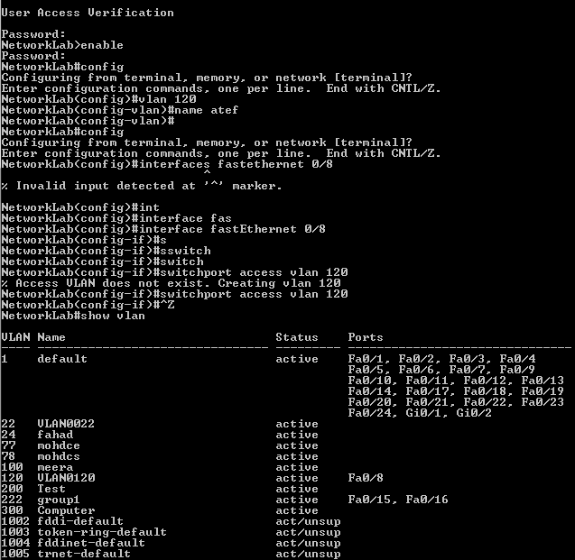We start by connecting to the telnet, using ‘telnet ip’ command to connect to the switch, then type the password and finally use the ‘enable’ command to be able to configure as follows:

Enable command

Enter password

Re-Enter password

Following up we create our Vlan by accessing the configuring status (‘config’ command), then we create said Vlan by giving it an ID and a Name as follow:

Naming said Vlan using ‘name’ command.

Vlan command and ID selection

Configure status

We set required interfaces through the following commands and exit configuration status to check the Vlan status:

Interface status and name

Vlan name

To check vlan status

Associate the interface with created vlan using vlan ID

‘Interface fastEthernet intNumb’ command to specify the needed interface

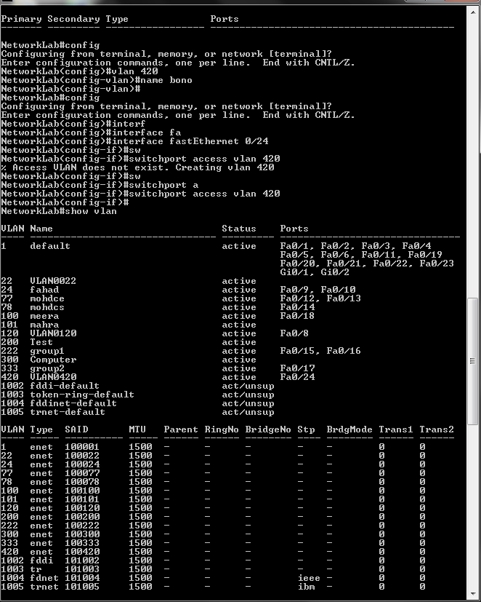For other interfaces we do the same:



We connect our PC to switch and ping the PCs on the same vlan and get the following:

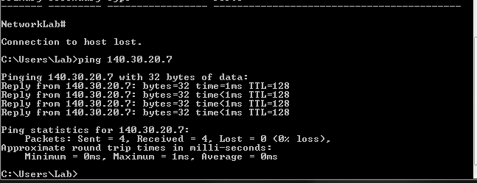

If not in the same Vlan we get the following:

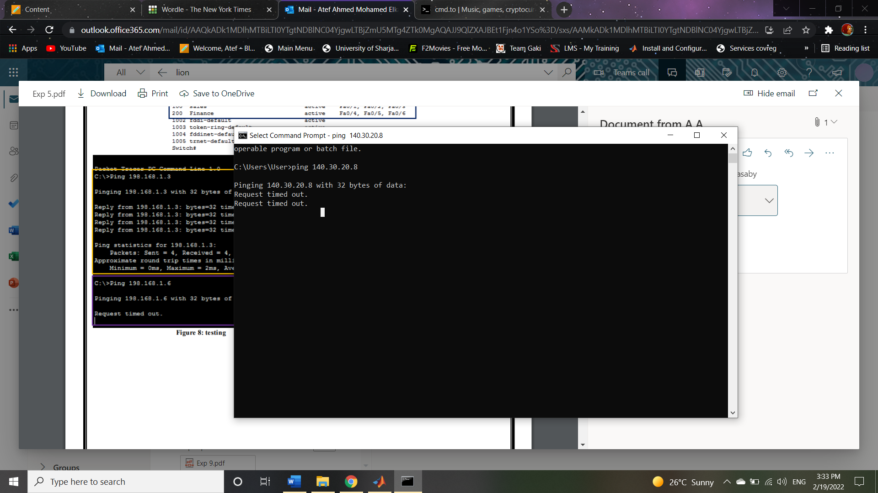

Finally, we will demonstrate Vlan trunking through packet tracer:

We will have 4 PC’s all connected to two different switches, PC0 and PC3 to Vlan 120 and PC1 and PC2 to Vlan 420.

1. Create network and connect PCs to the switch’s ports( Cross connection for same devices):

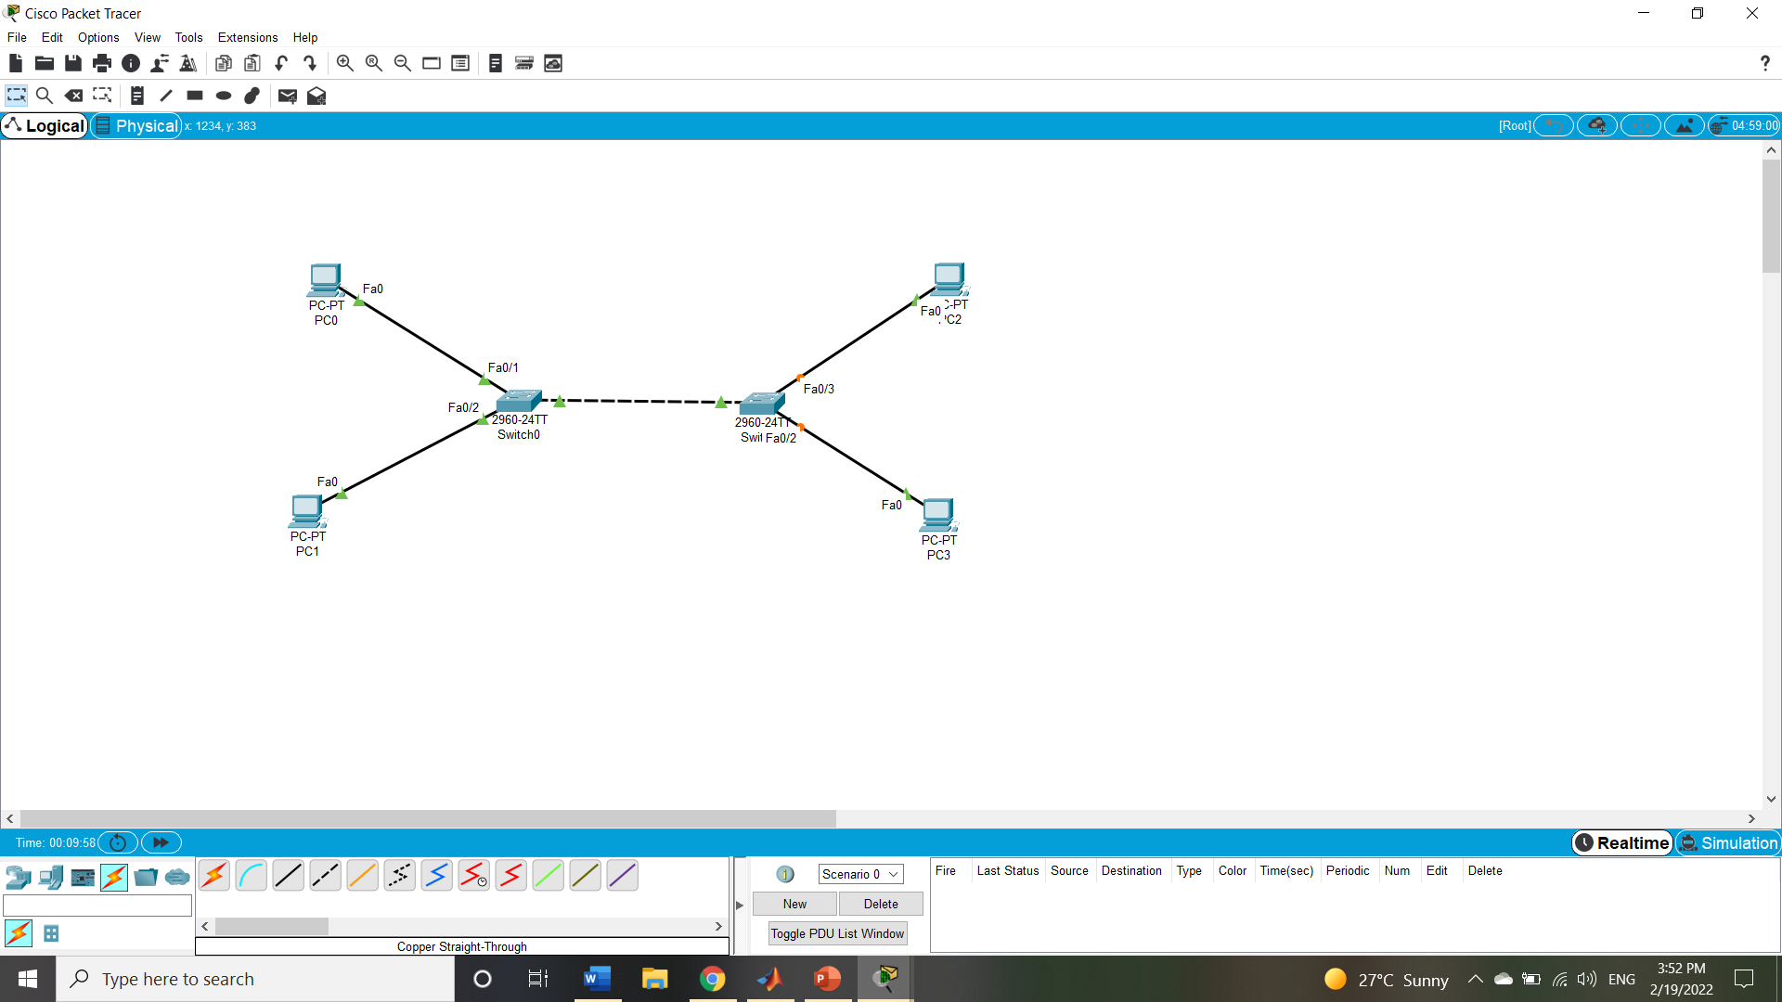

Vlan 420

Vlan 420

Vlan 120

Vlan 120

1. Configure the IP of each of the PC’s:

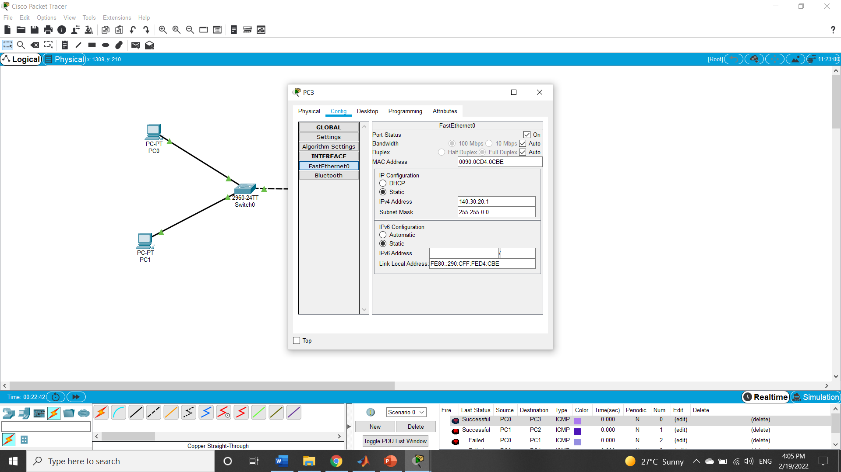

1. Start creating Vlan’s, we enter config status and create Vlans and ID’s for both we are using, here it’s one for computer science and other for computer engineering: 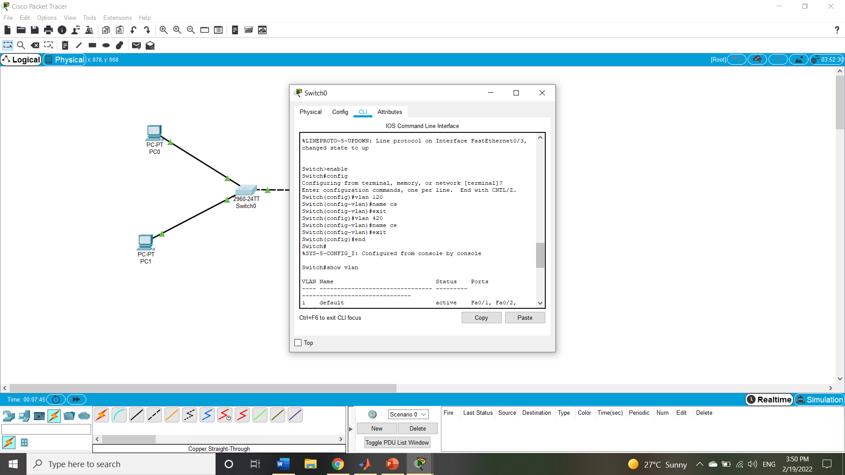
2. Show status and names of created Vlan’s:

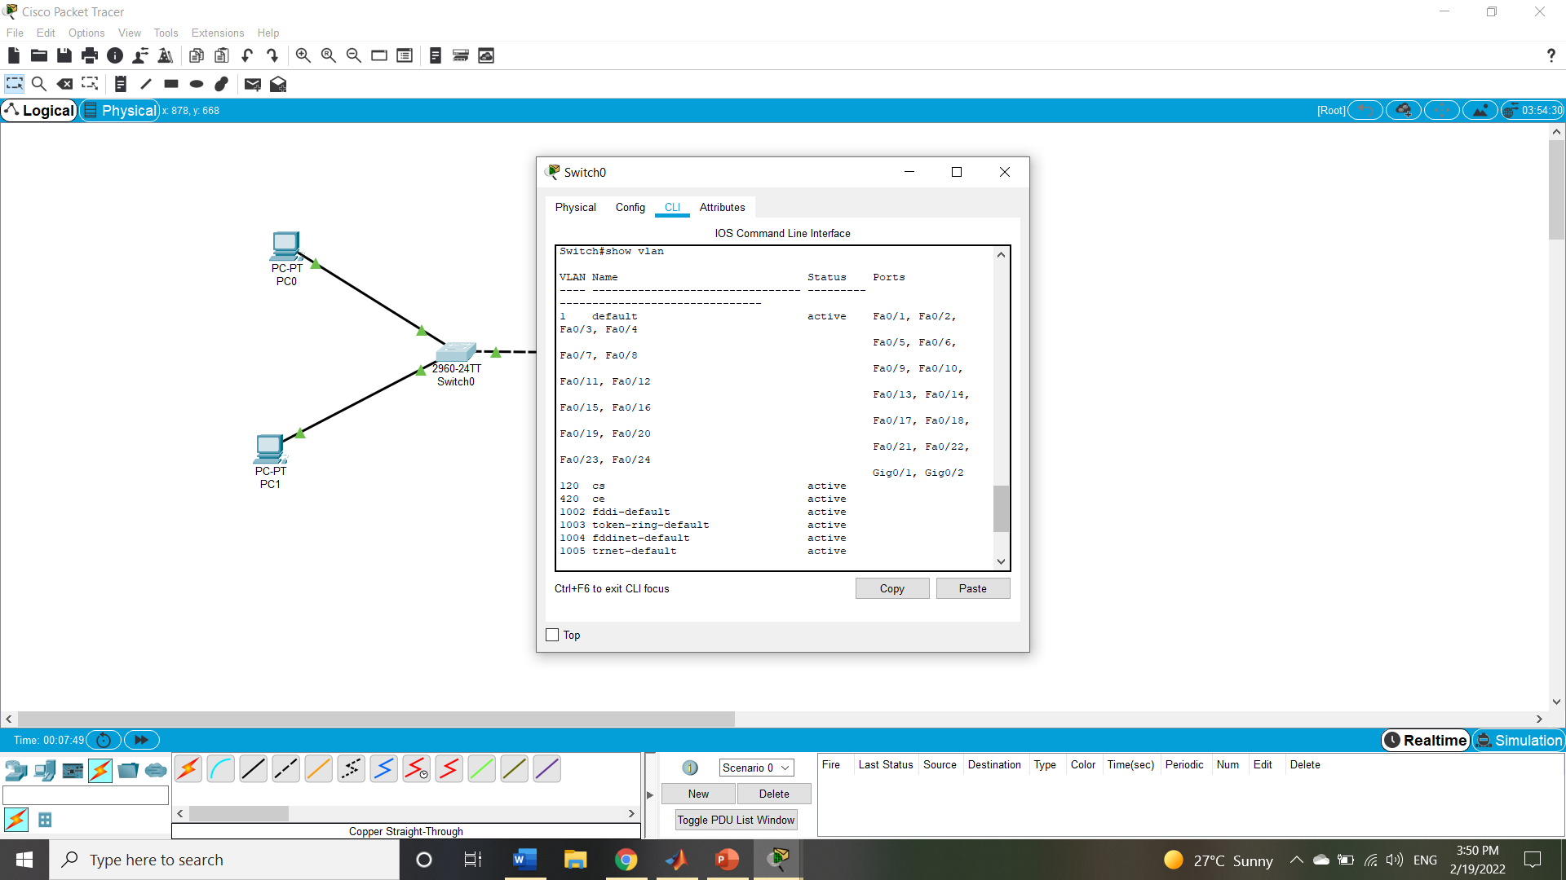

1. Add each PC to correct Vlan through the right known interface from connecting to the switch:

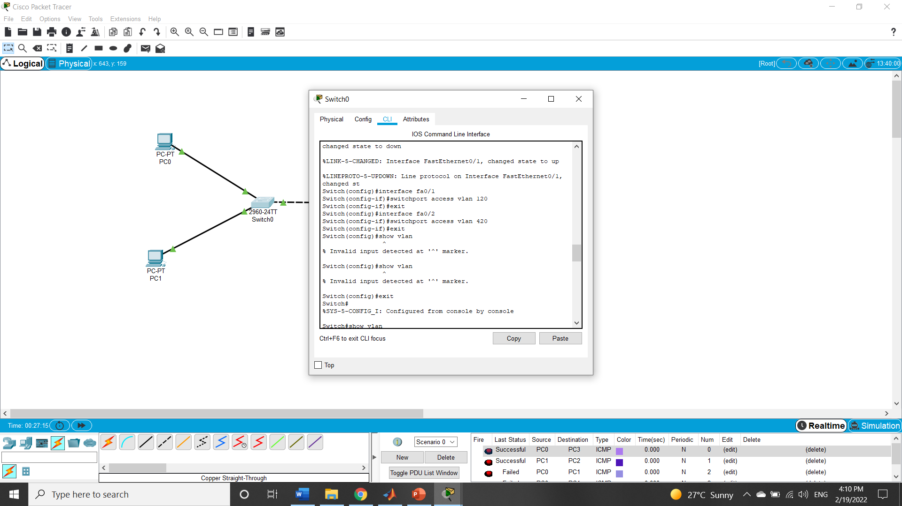

1. Showing connected interfaces and status on each Vlan:

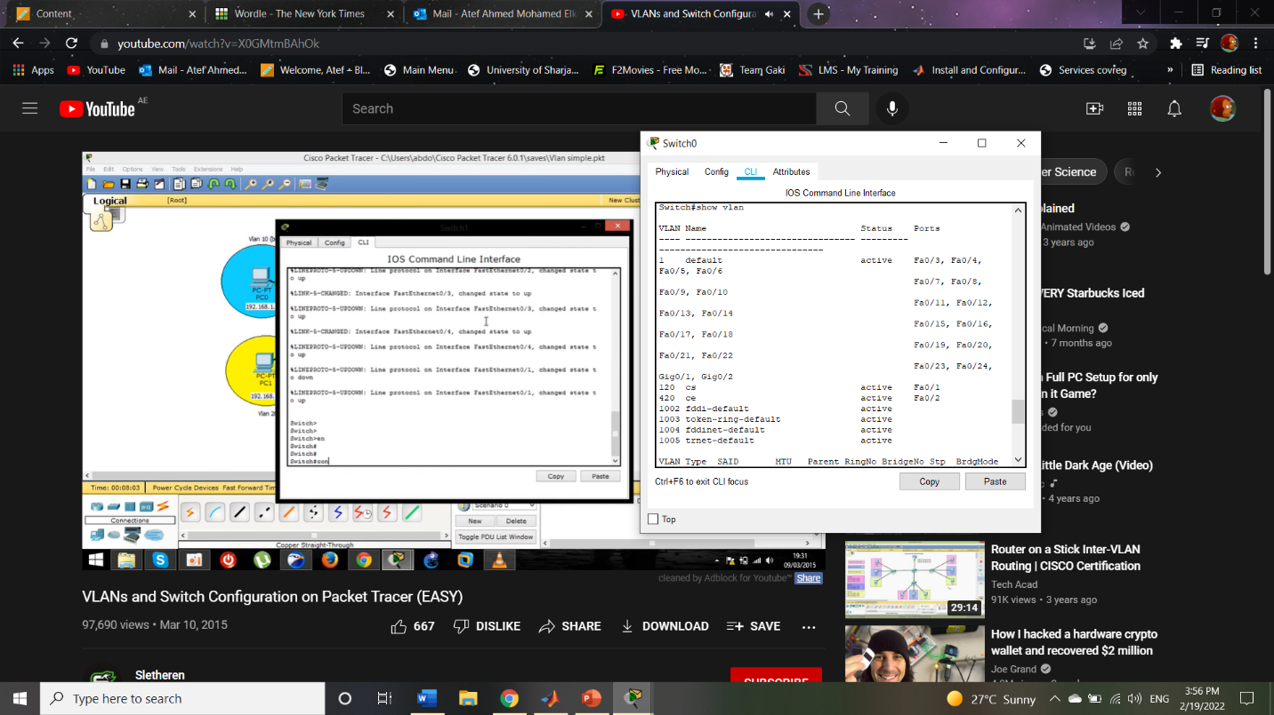

1. Thorough the following command we will trunk the switch port to be able to communicate with similar Vlans on another switch, using the command (switchport mode trunk) to switch mode to trunk:

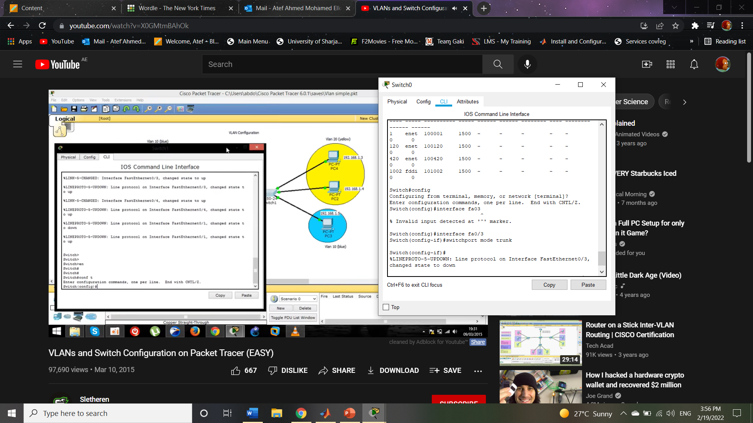

The interface that is connected to the other switch

1. Do the same with the other switch and PC’s:

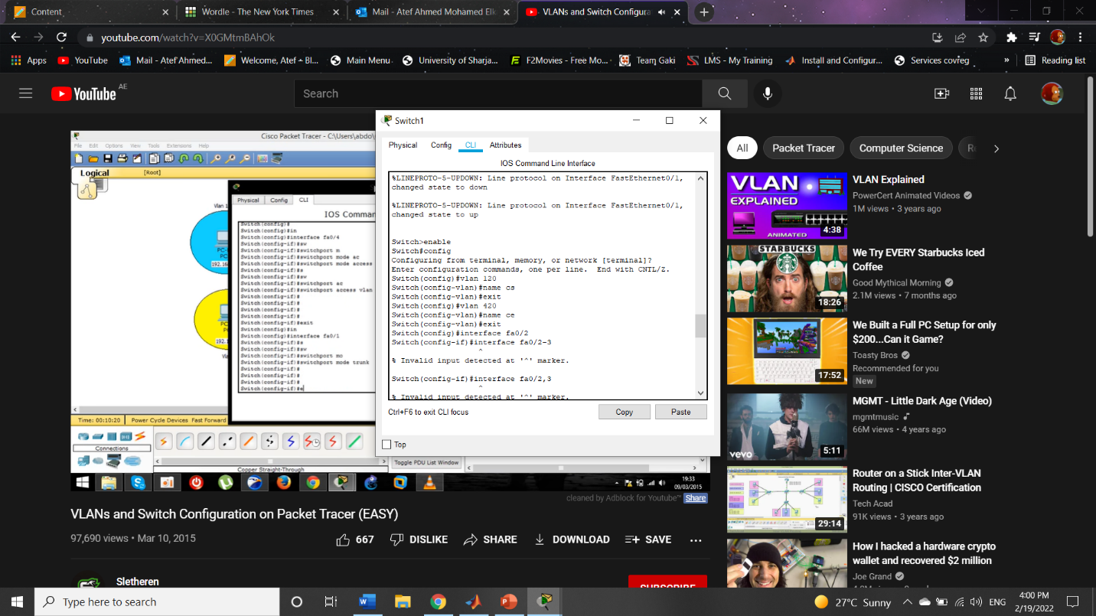

1. Configure the interfaces:

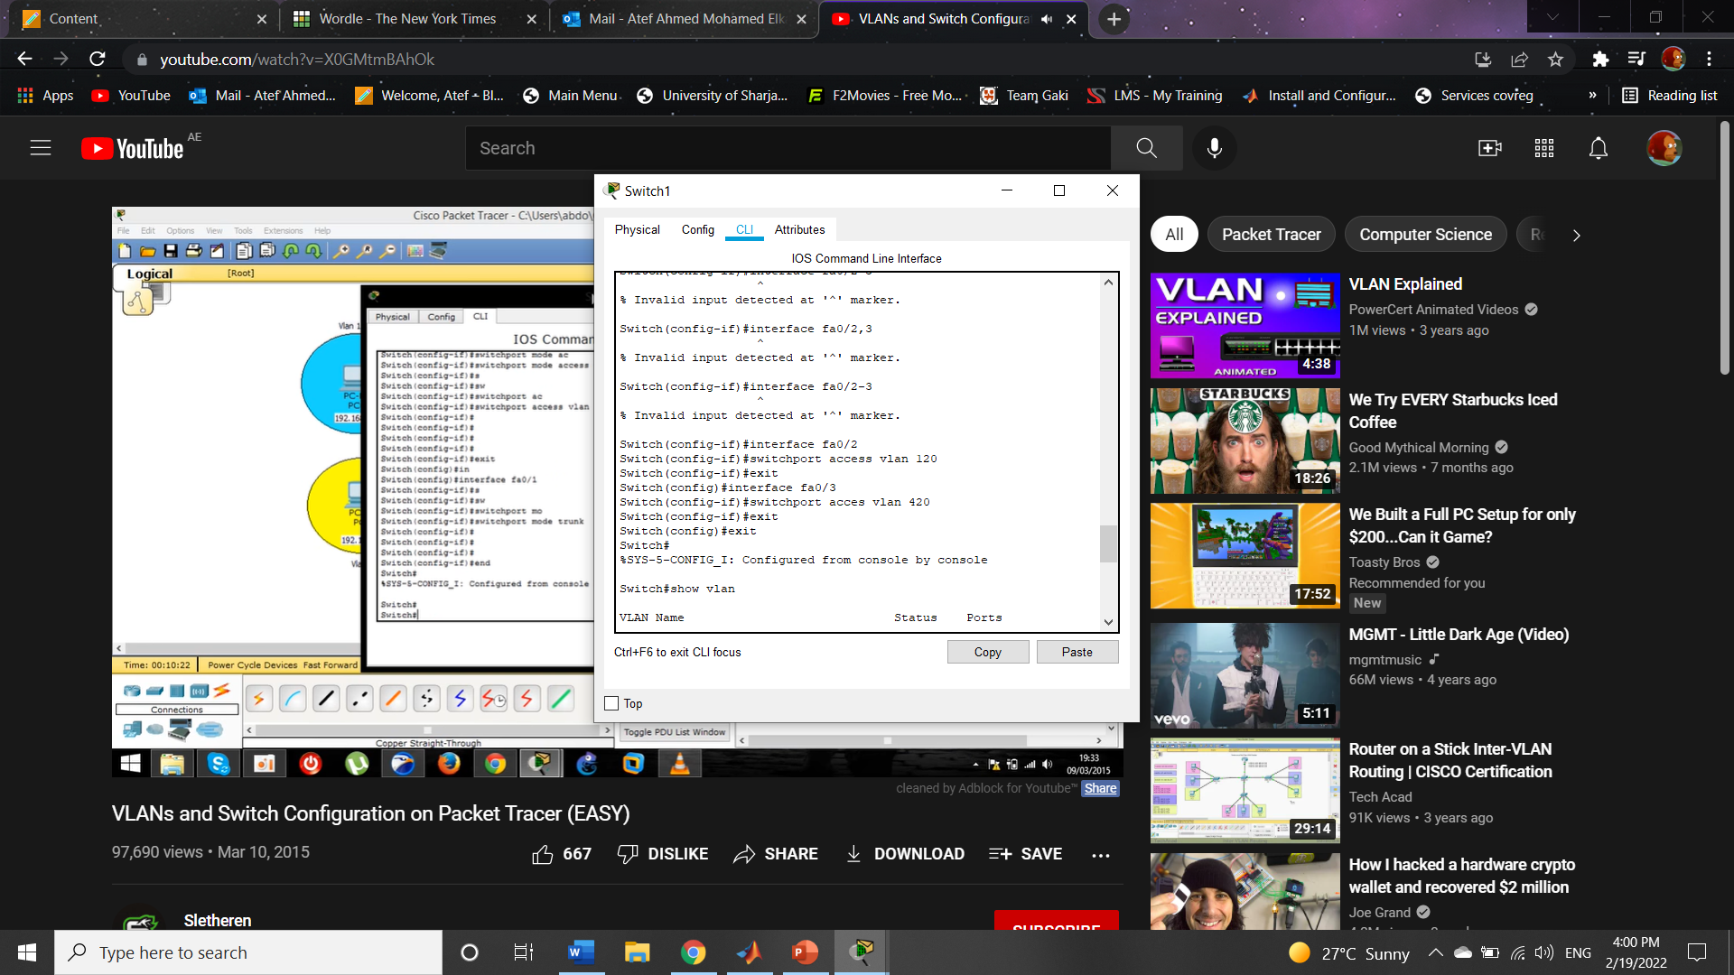

1. Show the connected interfaces to right Vlans:

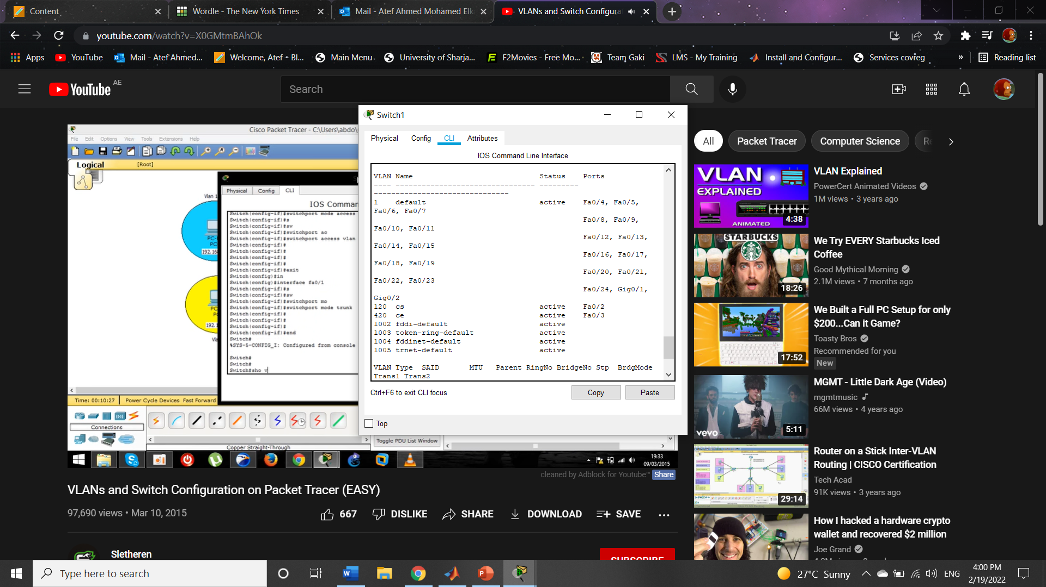

1. 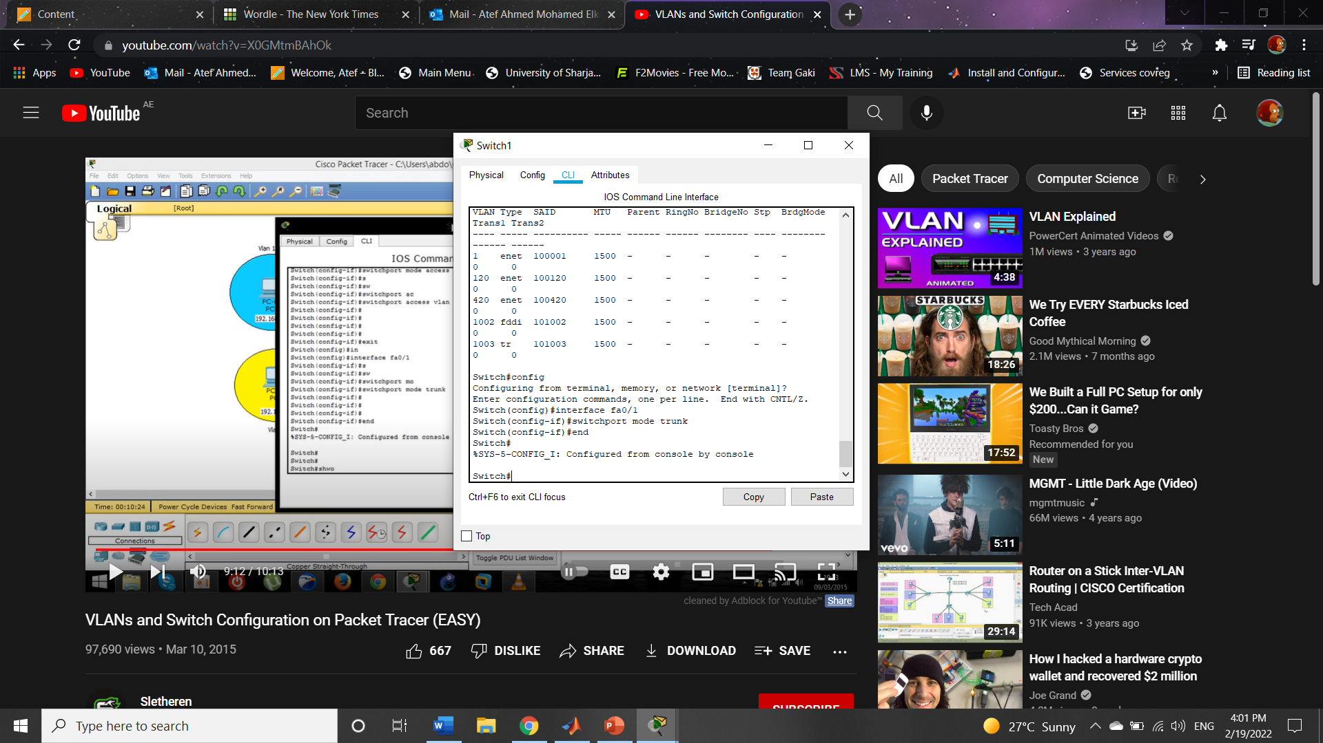Trunk the switches port that is connected with other switch to trunk both networks and for the PC’s on the same Vlans to communicate:
2. 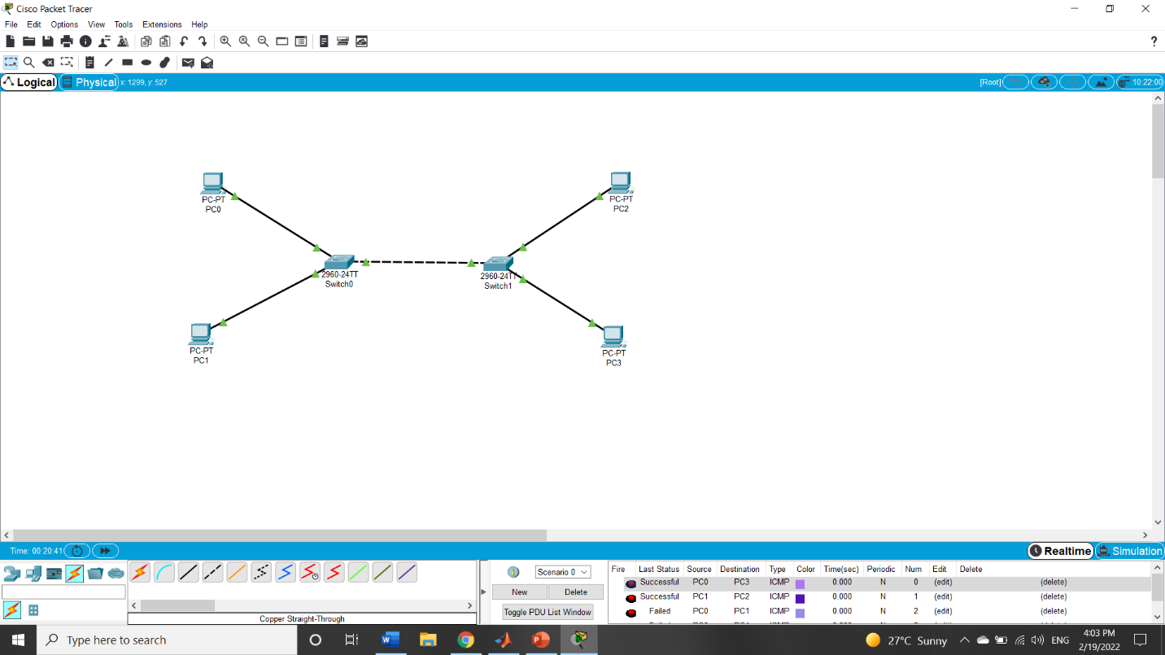At the End we ping through PC0 and PC3 and find a successful ping on VLan 120, also a successful ping on VLan 420 PC’s, but a ping failed between PC0 and PC1 because they are not on the same Vlan.